# INTRODUCTION

This project aims at solidifying the basics of front-end web development among students. Our goal was to make an e-commerce site, a blog, portfolio for each team members and a feed-back form. Working on this project will help us be familiar with the basics of HTML, CSS and JavaScript, which are an integral part of web development.

Our websites name is Origin Bonsai. We have tried our best to make a well-functioning and cohesive website using what we know. It was not easy to put everything together and make the website look good. Every team member had their own ideas and aspirations, to homologate all those different ideas into a website was the most difficult part. But I am confident that our team has done their best and has created a website we all are proud of.

Our team members are Roshani Karkii, Sakchyam Thapa, Dibbeshwor Acharya and Yogal Thapa Magar. Roshani designed the products page, blog page. Sakchyam the Homepage and about us section. Dibbeshwor designed the feed page, feed back page, reference page and the cart page.

## Goals

The main goal of this project is to make a e-commerce website with a blog, feed-back page and portfolio using vanilla JavaScript, HTML and CSS. We are not allowed to use any frameworks or libraries. This is to help us learn the fundamentals of how HTML, CSS and JavaScript works before diving into the more advance stuff. The website must be easy to navigate and lead to sales of bonsai. The product page must be intuitive and lead to sales of bonsai plants.

## Objectives

The objectives of this project are quite straightforward, to make a cohesive and intuitive e-commerce website. The website needs to have an easily understandable interface that even a beginner can use. We need to make sure that there is uniformity in interaction throughout the website. We have decided to implement a slider in the feed page that cycles through the various posts. The cart page itself is a dummy page but when buy now is clicked, the number in the cart increases, indicating that a product has been added. A function form is also implemented in the feedback page.

## How HTML, CSS and JS was used

HTML stands for Hypertext Markup Language.HTML was used to provide the webpages a basic structure. It was used to separate the content, make navigation bars for forms, add buttons, sentences, paragraphs, photos, and icons, among other things. HTML5 was employed while working on this project. HTML is like a skeleton of a website, giving it structure.

CSS stands for Cascading Style Sheet. CSS was used to regulate the formatting, organization, and presentation of the webpages. It is used to give the website style. It is in charge of the stylistic work done on the homepage, including the background color, image size, placement of the contents, font family, font style, and many other things. This project uses inline, internal, and external CSS. Internal CSS was used on components that required separate styling on different pages, while external CSS was used on elements that were shared by all five web pages. If HTML is a skeleton, CSS is the flesh and dress of a website.

JS stands for JavaScript. JS was utilized in this project to regulate the behavior of various website elements. It is in charge of the webpage’s alert message popups, image slider, and form validation. In this project, JS from both internal and external sources is employed. JS is like the brain of a website, giving it logic and functionality.

## Verdict

As this project is only a simple E-commerce website prototype, using HTML, CSS, and JavaScript was sufficient to finish it. HTML, CSS, and JS alone wouldn’t be sufficient for a real-world project because doing so would be time-consuming and occasionally annoying.

Numerous issues plagued us, including images that covered the text, material that wasn’t correctly centered, extra space between the contents, JS that couldn’t get the value of the form box, etc. We were able to identify my errors and find solutions to all of those issues,

# DISCUSSION AND ANALYSIS

## Text Editor

Text editors are programs or word-processing software used to input and edit content. Text editors include, but are not limited to, WordPad, Notepad, Notepad++, Sublime Text, etc. (TechTerms.com, 2022).

For this project, the text editor of choice is Visual Studio Code, an IDE (Integrated Development Environment) program. Compared to other text editors, it is quite helpful since it has many features like prettier, which is a code formatter that neatly formats the code and makes it seem beautiful, go live, which enables editing HTML and seeing real-time changes without refreshing the browser.

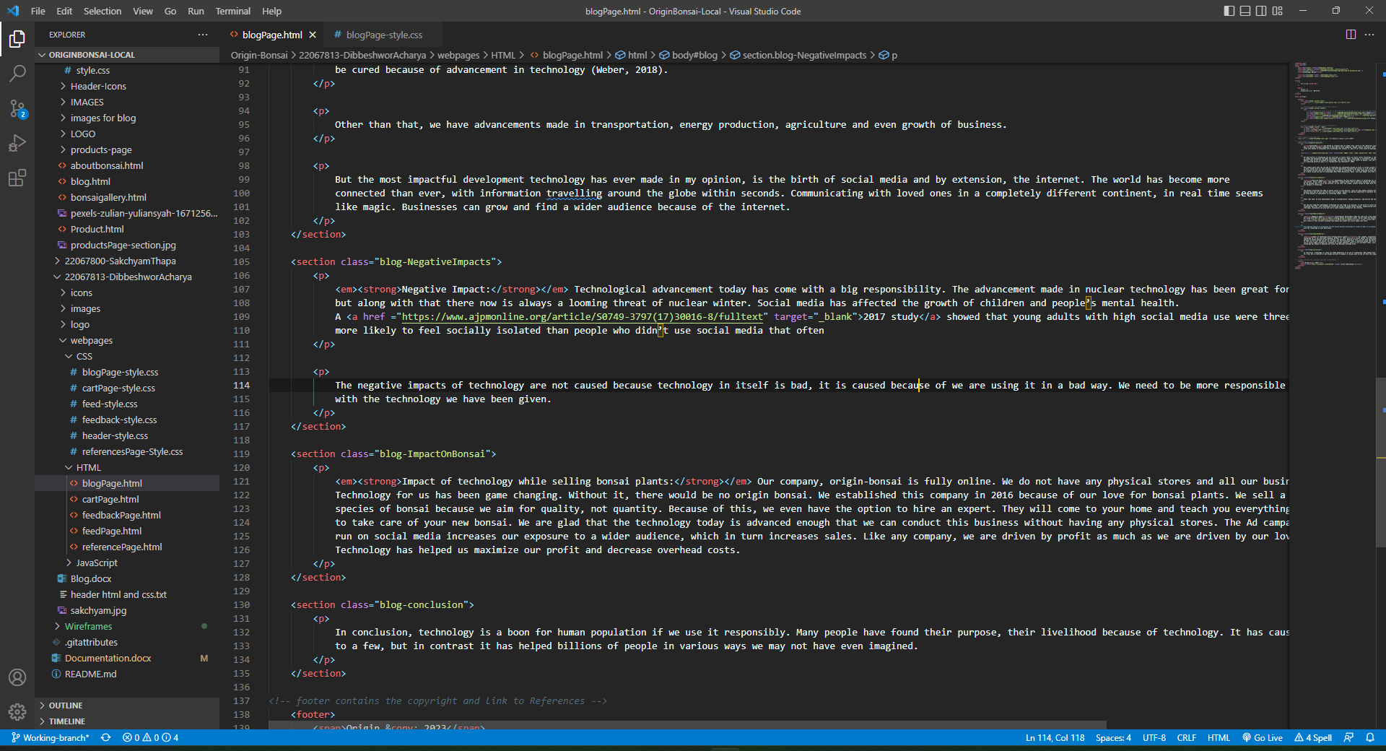

Figure : Vs-code

## Wireframe tool

When designing a website at the structural level, a wireframe tool is employed. Before adding visual layouts and content, they are used in the early stages of website development to create the fundamental framework of a page. (ExperienceUX, 2021).

The wireframe of the webpages in this project were designed using Balsamiq Wireframe. It is incredibly user-friendly and all the functions are simple to use which was really helpful for beginners like us. Having a wireframe tool to pre-design your website roughly was really helpful.

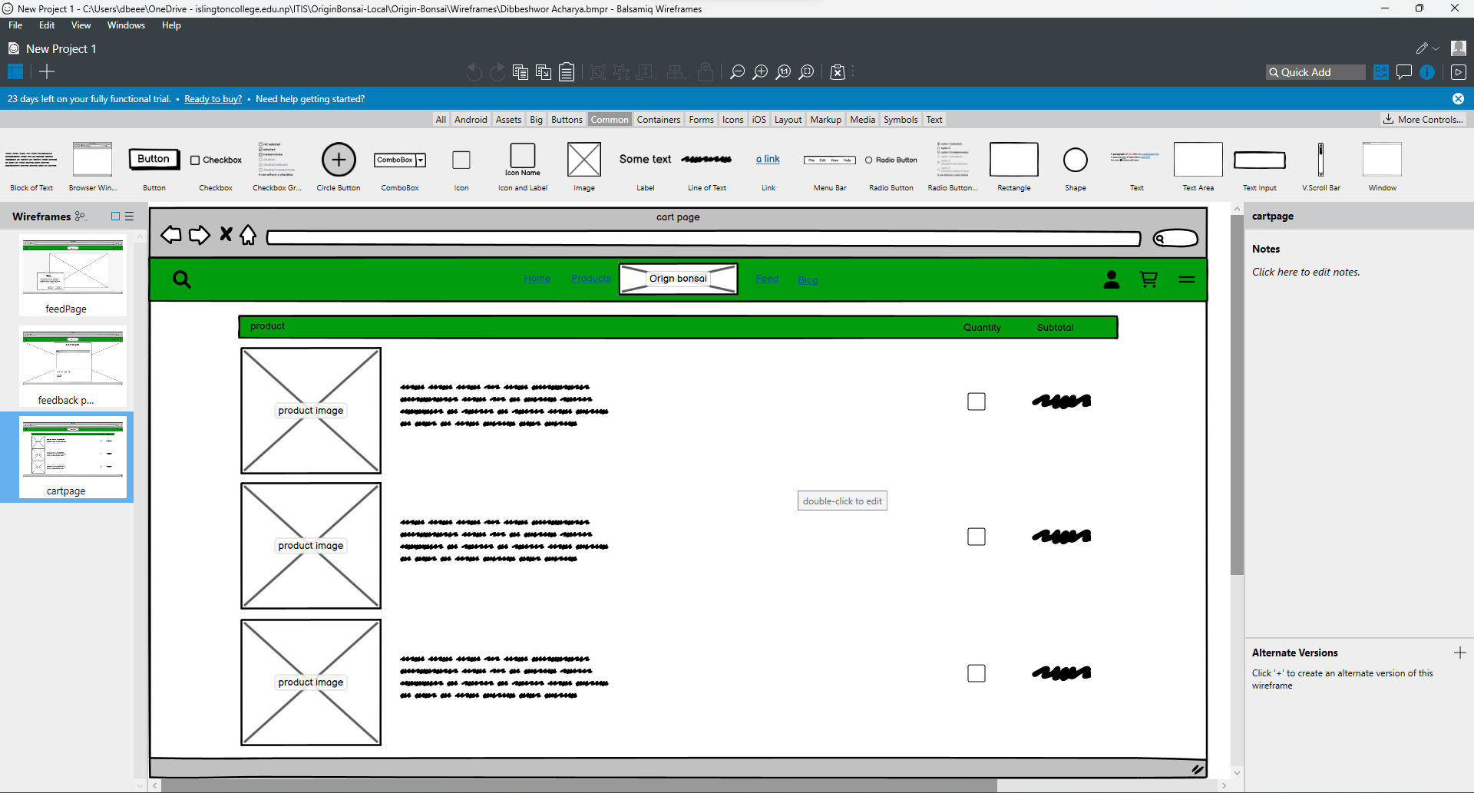

Figure : Balsamiq wireframe

## CSS used

The properties of CSS used in the project are as follows:

• Display: indicates how an element will be shown; display: flex was mostly utilized in the project.

• Flex-direction: indicates the direction of elements inner a flexbox.

• Width: used to determine the breadth of an element.

• Background: used to set the picture or backdrop color.

• Height: used to determine the height of an element.

• Font-weight: used to indicate how bold a text would be.

• Color: used to determine the text’s color.

• Text-align: used to modify the alignment of text.

• Z-index: used to indicate stack order of elements; element with greater zindex is always on front; its default value is 1.

• Opacity: used to change the clarity of an element.

• Flex-basis: indicates the initial length of flexible item.

• Margin: sets the margin of an element, which controls the container's outside space.

• Padding: sets padding for a component that occupies the container's inside area.

• Box-shadow: used to provide shadow to an element box.

• Align-items: indicates the alignment of element inside the flexbox.

• Justify-content: aligns the flexible container's contents when they don't occupy the entire horizontal area.

• -webkit-text-stroke: provide stroke to the text.

• Border-radius: indicates the radius of the border.

• Font-size: indicates the size of the font.

• Line-height: indicates the height of each line.

(W3School,2023)

## Name of webpages

### Homepage

The project's home page is its primary page. When the project is opened, this page is the one that loads initially. A quick overview of the whole e-commerce website, including some of its services, is provided on this page. It includes the categories of bonsai available along with our features.

Major tags used:(style, nav, meta, header, div , img, a, section, li, button, footer, hr, script, input, br)

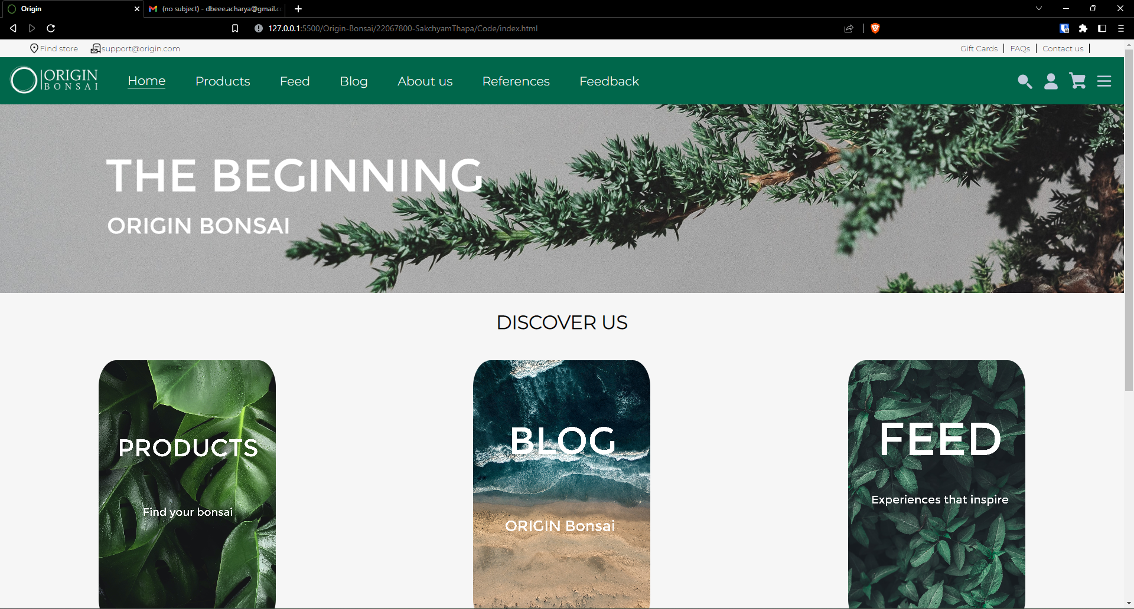

Figure : Homepage

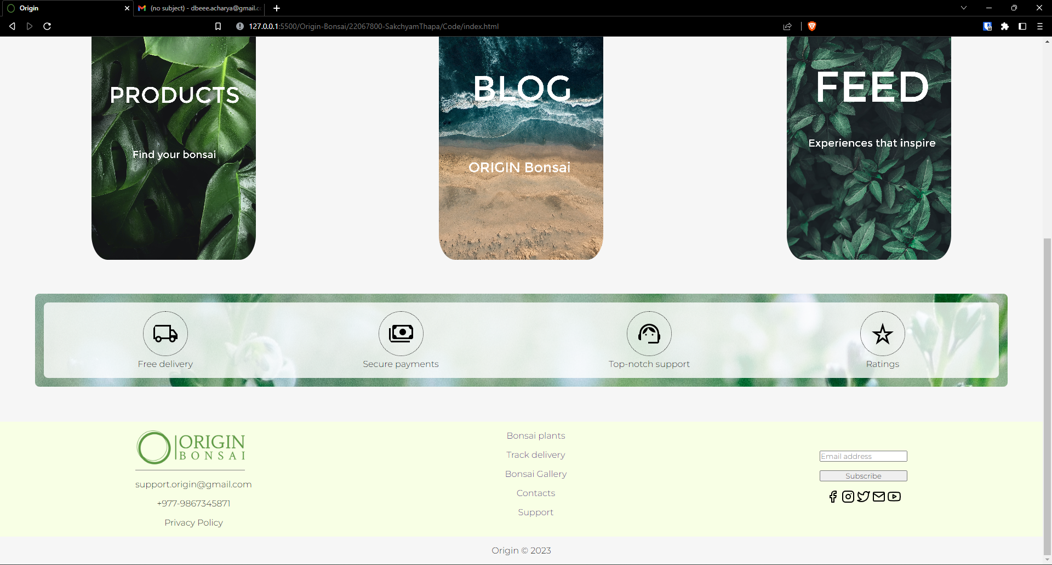

Figure : homepage 2

The wireframe for homepage is given below:

### Products Page

This page includes descriptions of all product categories and the items themselves that are available in the store, along with their names, prices, and descriptions.

Major tags used: (style, meta, nav, header, div, img, a, ul, li, button, footer, br, input, form)

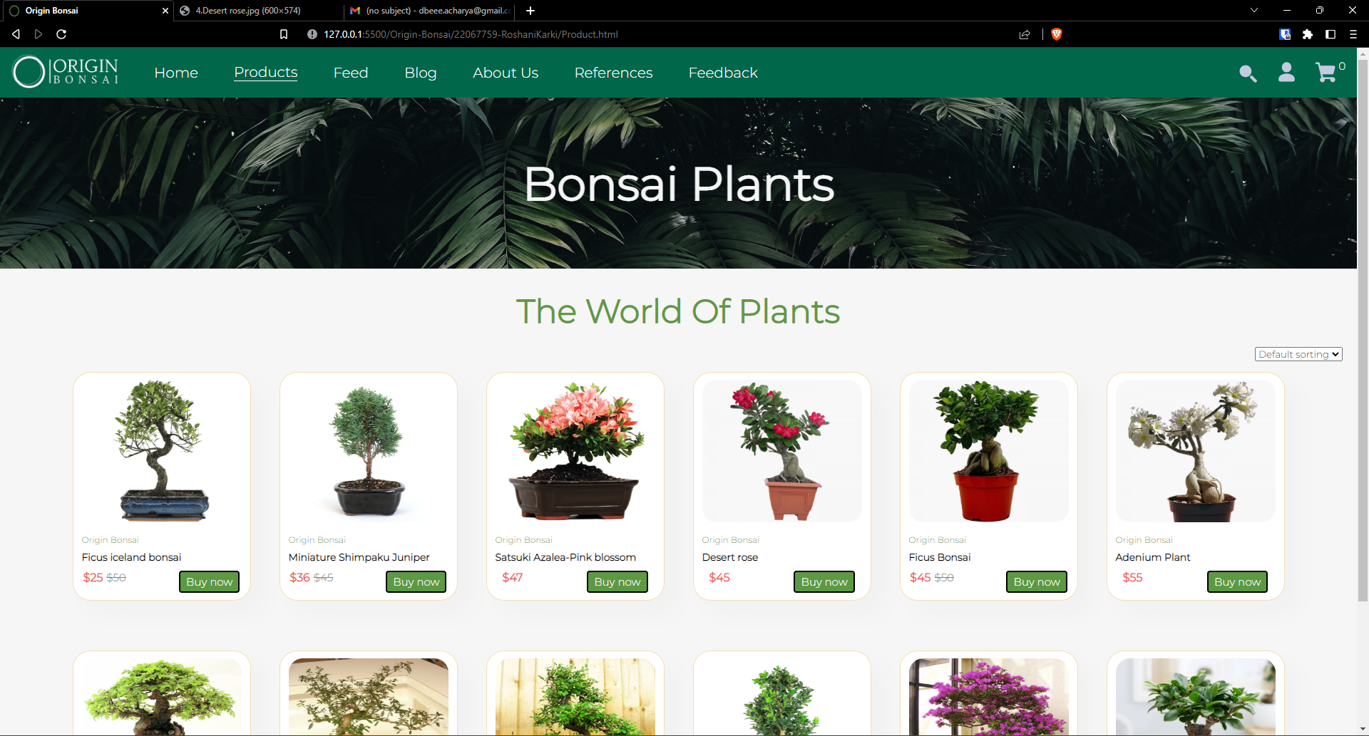

Figure : Products Page

Products page wireframe:

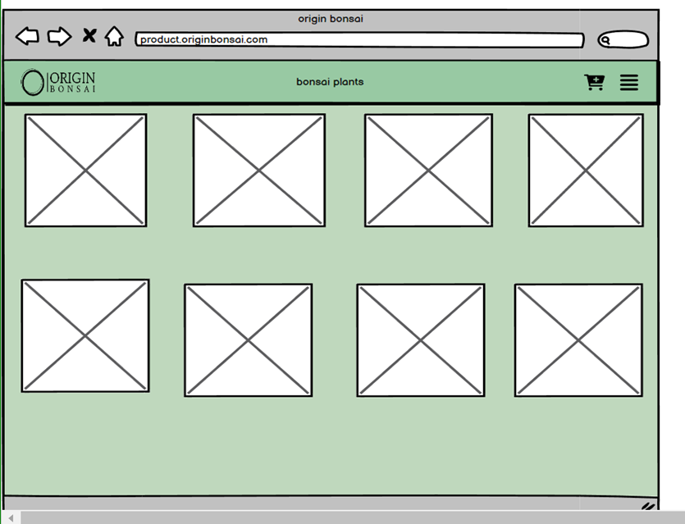

Figure : Products Page Wireframe

### Feed Page

This page was designed to accommodate the various stories our clients might have with their bonsai plants. It contains a short title with the image of the bonsai. A javaScript slider has been implemented in this page.

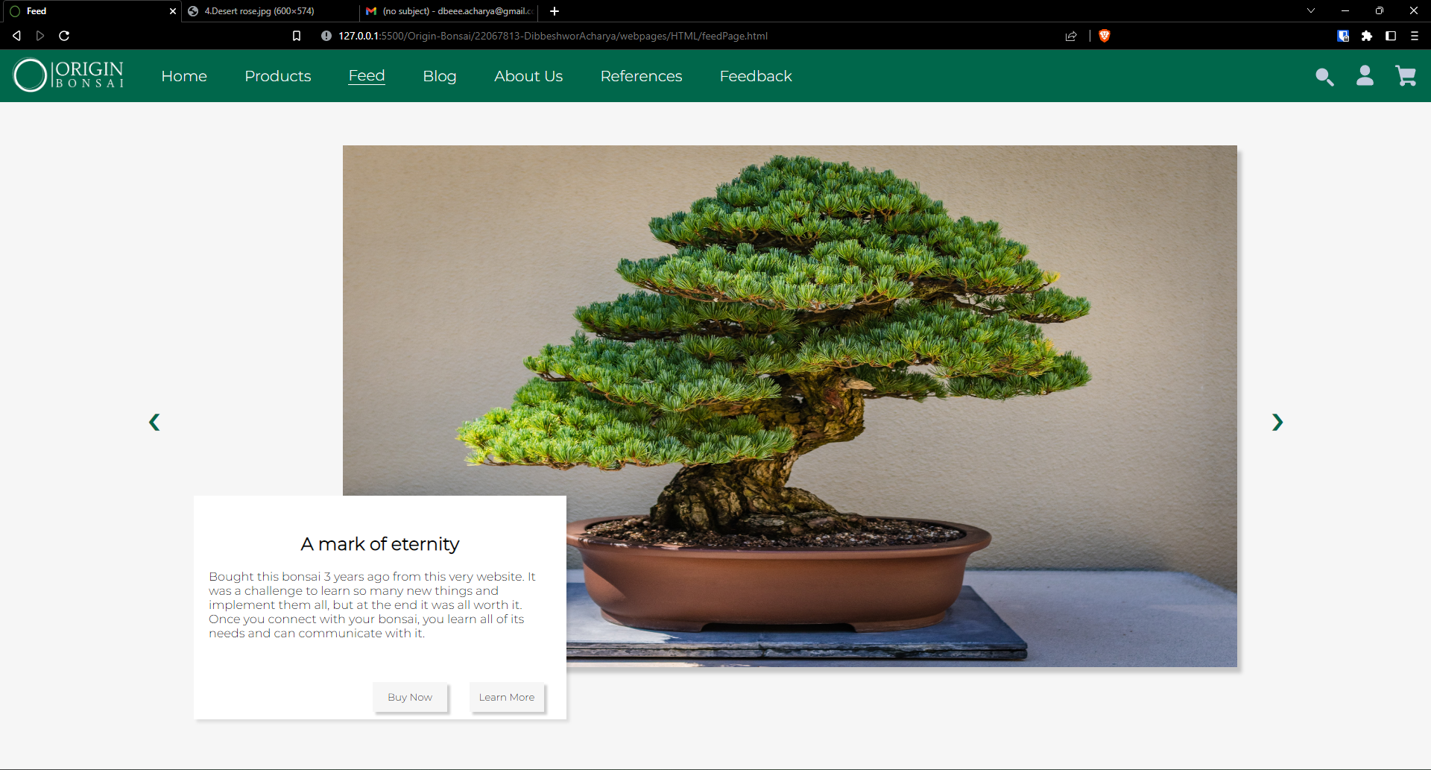

Figure : Feed Page

The wireframe for this page is given here:

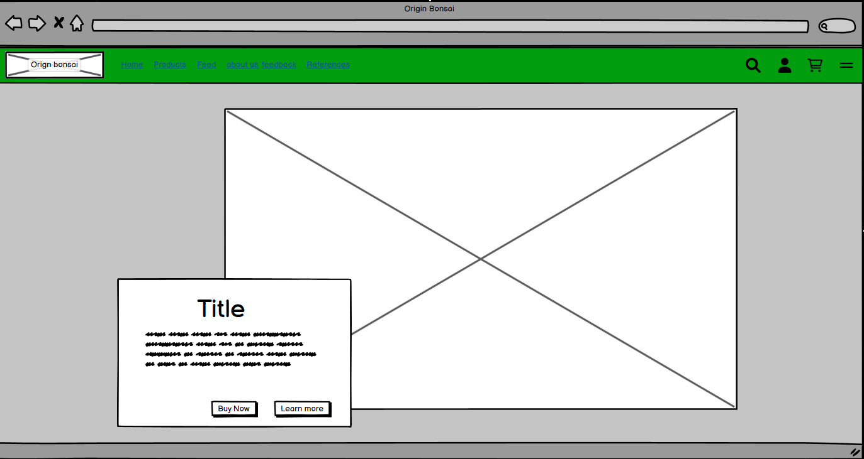

Figure : Feed Page wireframe

### Blog

This page contains various blogs written by our team, the highlight blog being about technology and bonsai. This page was designed to look a little random and playful because it is supposed to be a place to write our thoughts. There are three blogs in this page and also a bonsai gallery which contains a number of pictures of bonsai plants.

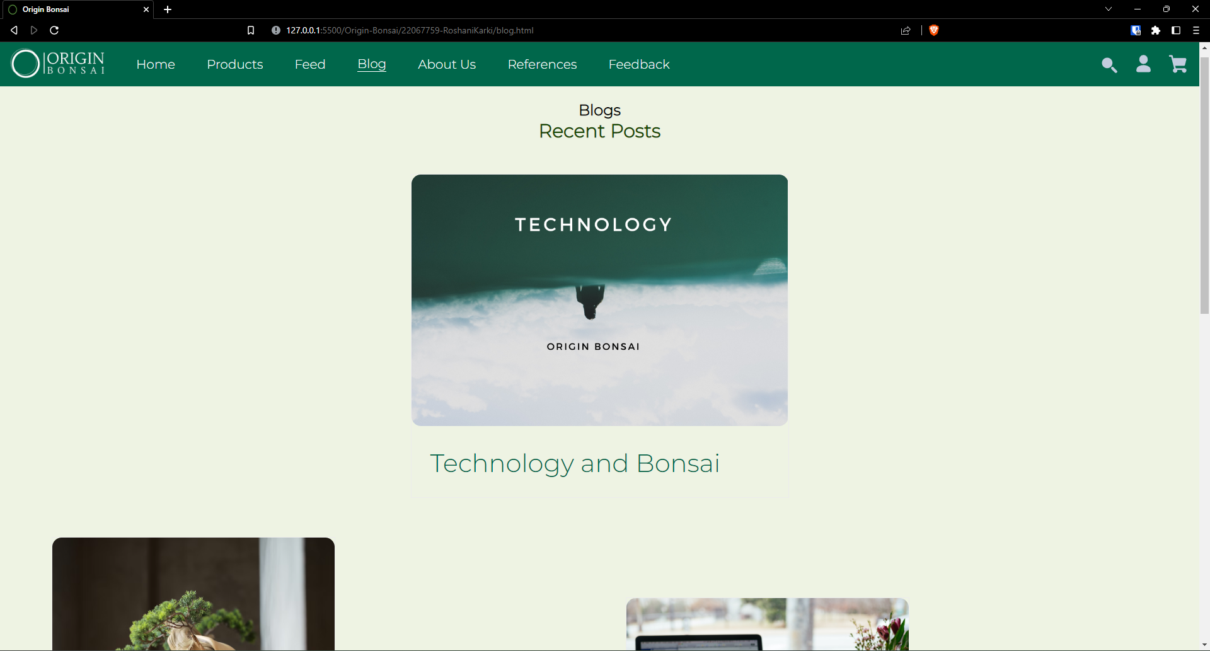

Figure : Blog page

The wireframe for blog page is:

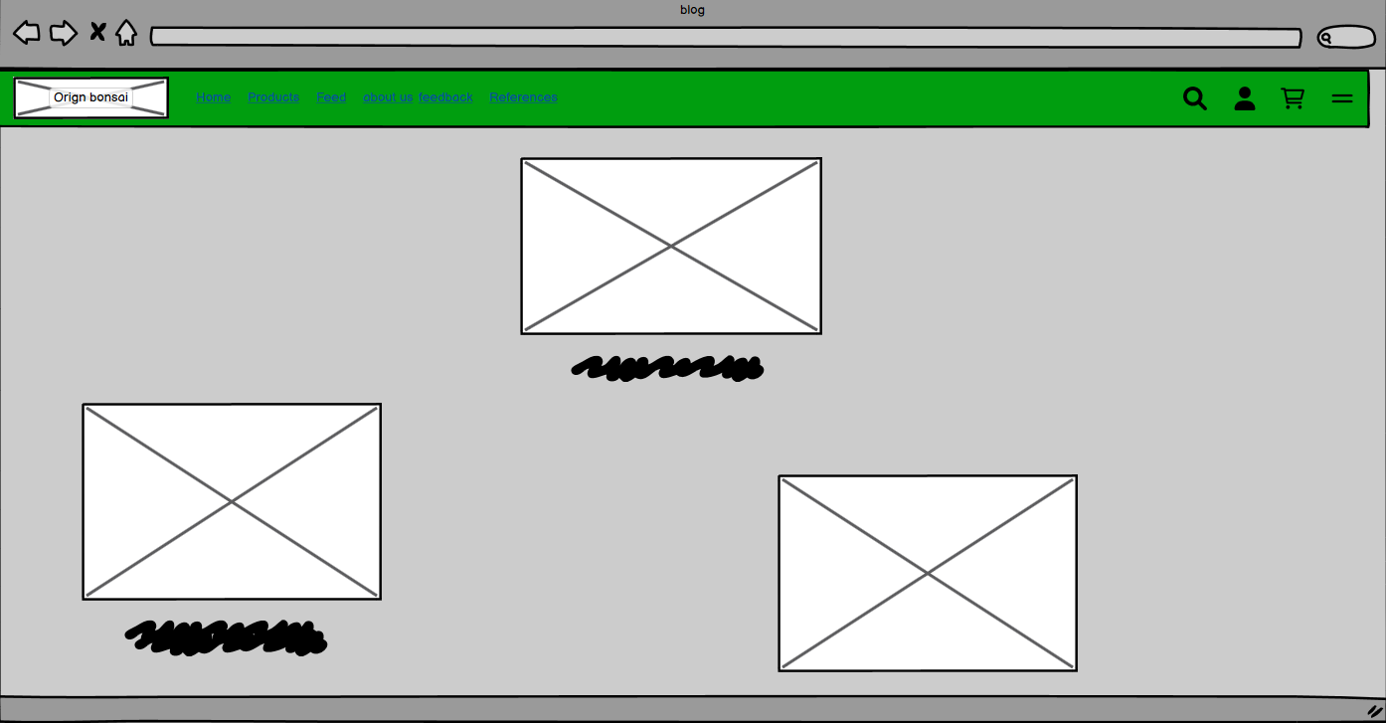

Figure : Blog Page wireframe

### About Us

The about Us page contains a detailed portfolio of each of our team members. We have tried to make this page unique and pleasing.

### References

References page contains the comparison between the page we have taken inspiration form and our implementation of that idea. We have given a short text that explains the contrast between the two webpages. Hover effect has been used in each of the images to make it easier for the user to see the image in detail.

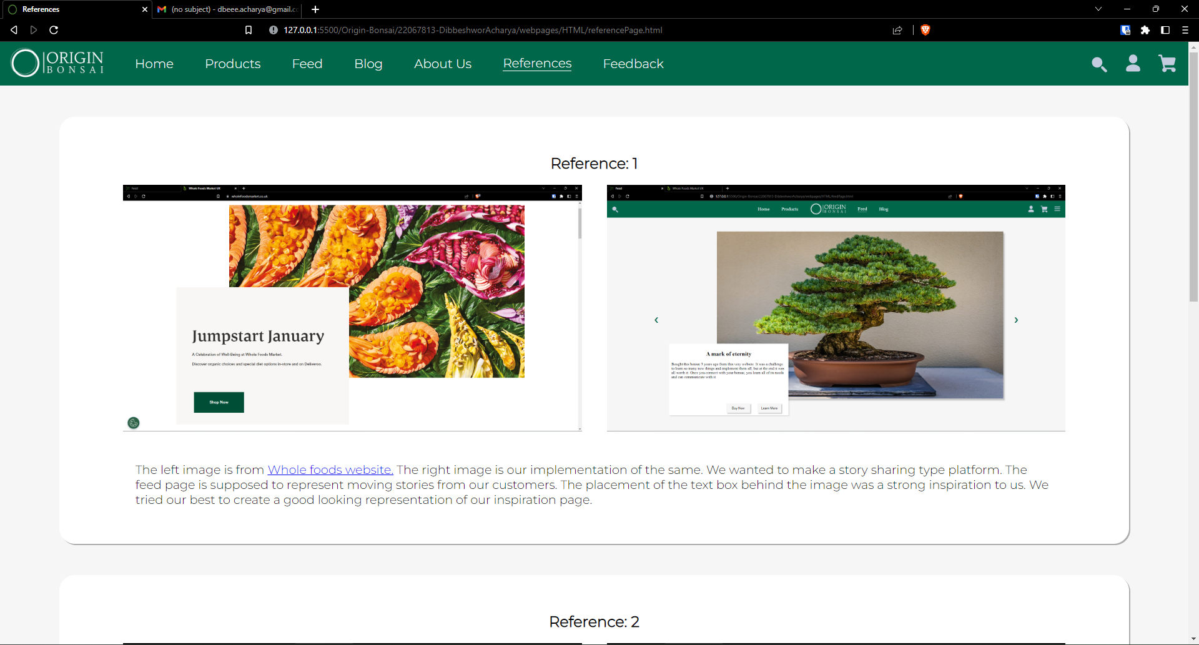

Figure : Reference page

Wireframe for the reference page is given below:

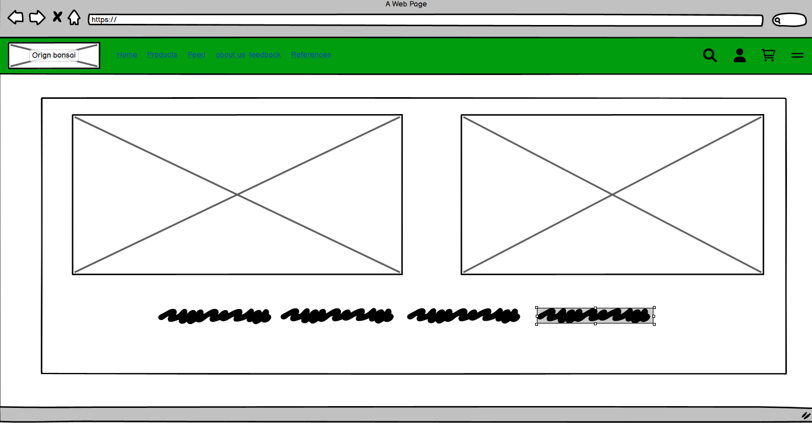

Figure : Refernce page wireframe

### Feedback Page

Feedback page as its name contains a feedback form for the user. There is a input field for name, email and a text area. We have also implemented an emoji rating system using JavaScript. The form is also validated before we submit it, which means that the user cannot submit the form with any field empty.

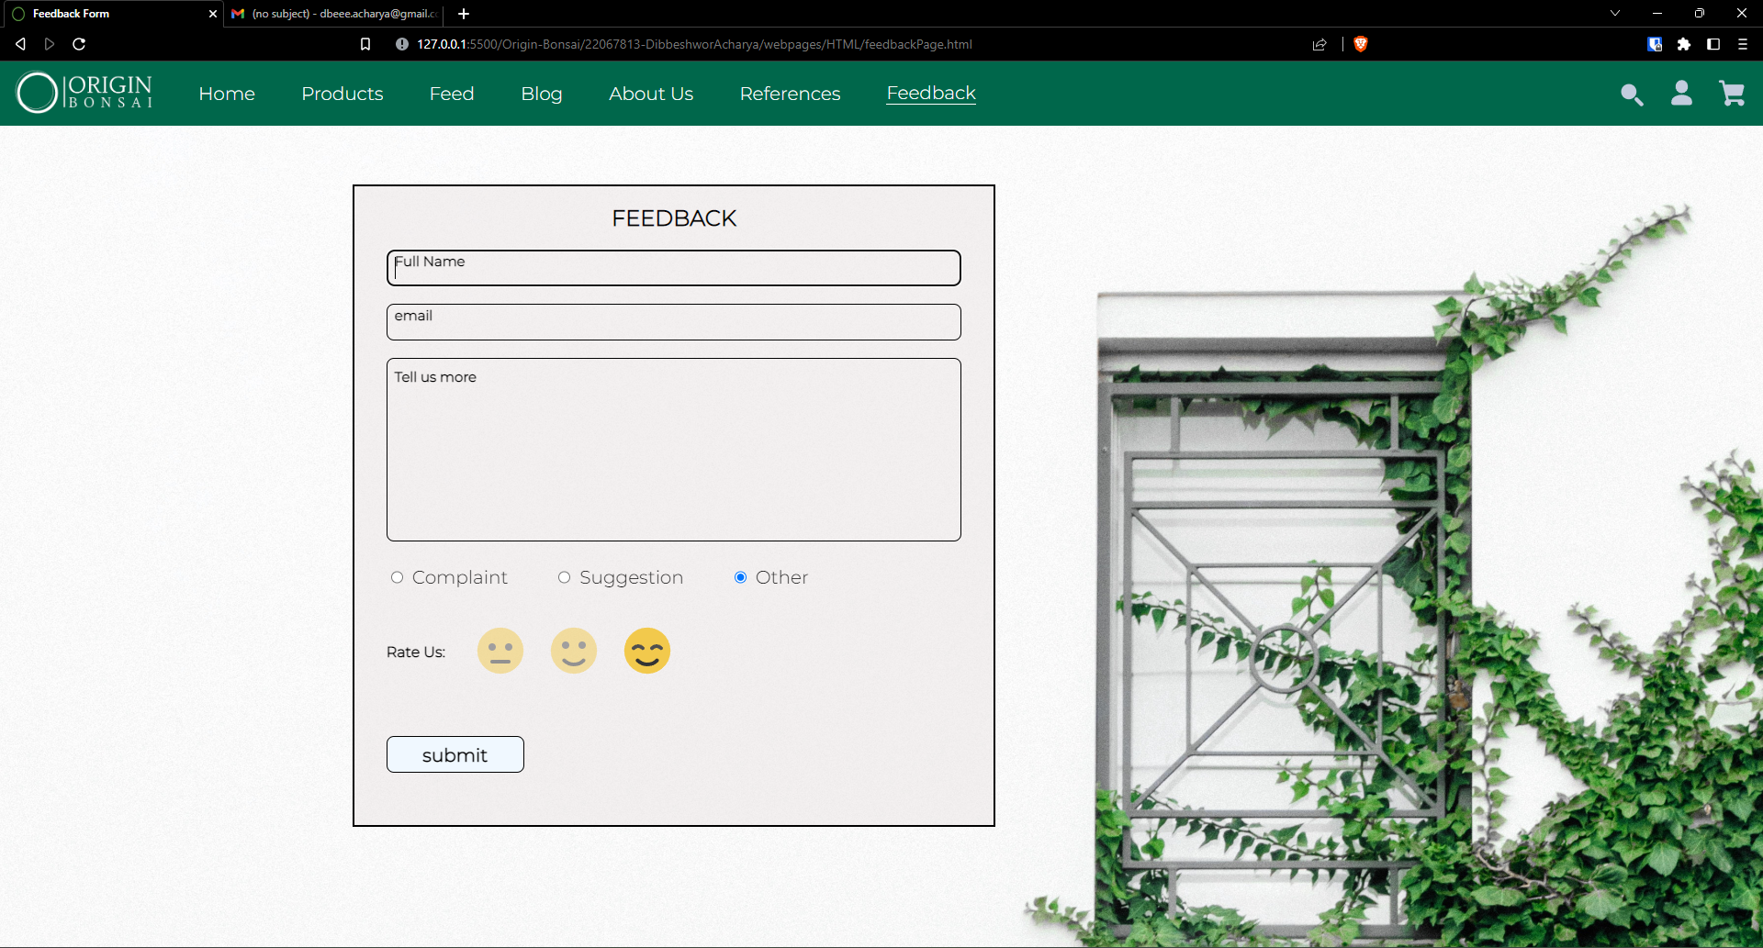

Figure : feedback Page

The wireframe for this page is given below:

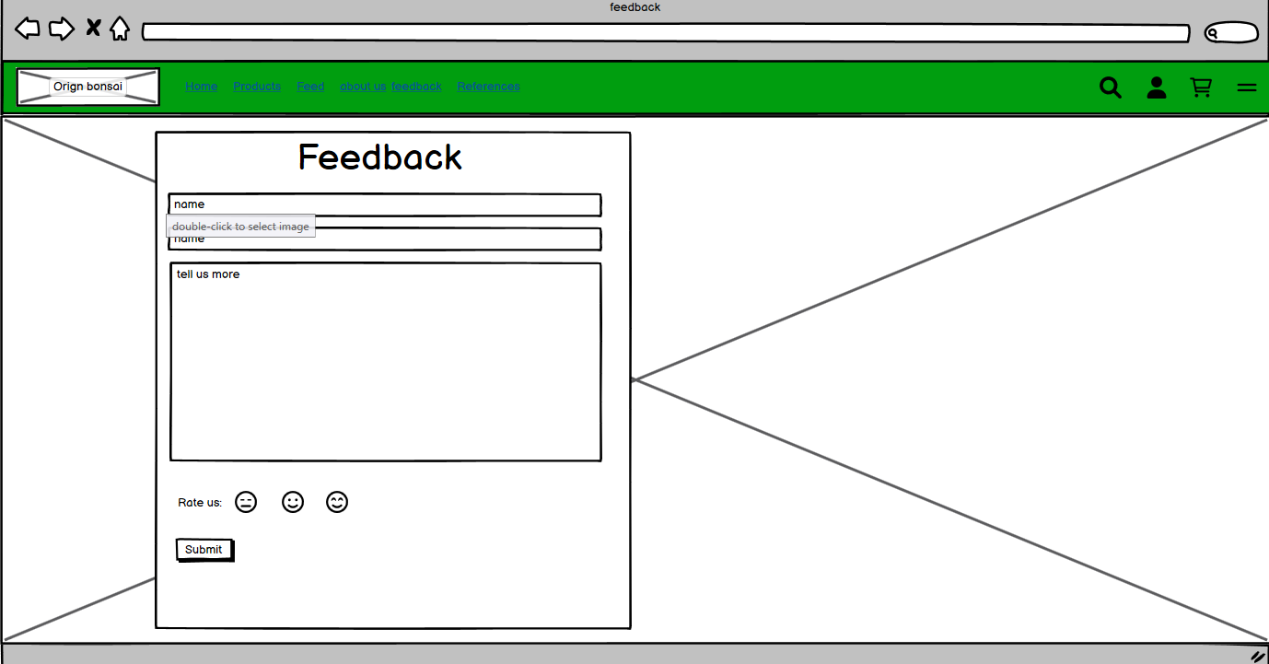

Figure : Feedback page wireframe

# TESTING

## JavaScript Testing

### Testing Form validation for feed-back Page

Table : Test1: Form Validation

|  |  |
| --- | --- |
| Test No: | 1 |
| Objective: | To Test if form is accepted only when all fields are filled |
| Action: | * Leave one field in feedback form empty * Check if error alert is shown |
| Expected Result: | When form is not filled completely an error alert is shown |
| Actual Result: | Error alert was shown when the form was not filled successfully |
| Conclusion: | The test is successful |

Let’s leave a field empty

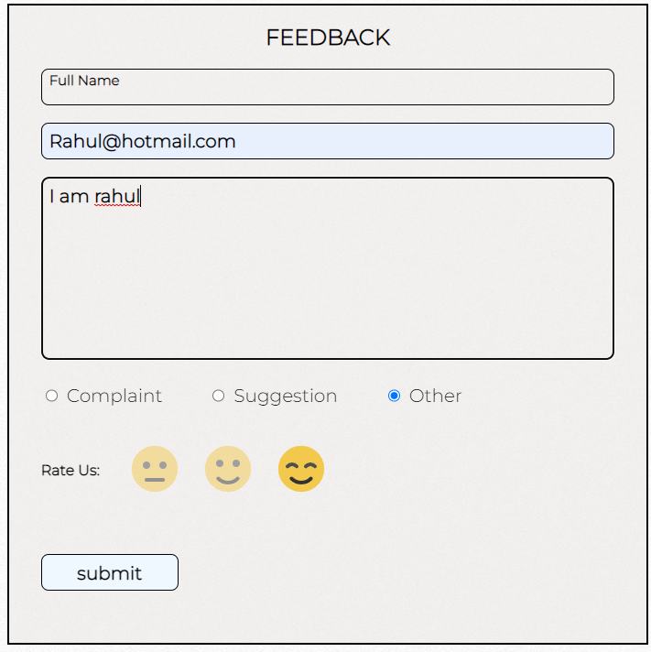

Figure : filling the form

As seen in the figure above, the name field has been left out empty. When we now try to submit this form, an error alert should be shown.

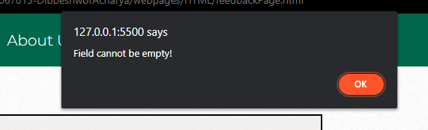

Figure : Error message for incomplete form

So, when we do not completely fill the form an error message is displayed.

### Testing “Rate Us:” emoji rating system

The emoji Rating System works by changing the opacity value of the selected emoji to 1 and the rest to 0.5. JavaScript is used to alter the CSS property of the images.

Table : Test 2: emoji rating

|  |  |
| --- | --- |
| Test No: | 2 |
| Objective: | To check if the emoji selector works |
| Action: | * Select lowest rating * Select middle rating |
| Expected Result: | When a selection is made, other emojis go back to being un-selected. |
| Actual Result: | When a selection was made, other emojis go back to being un-selected |
| Conclusion: | The test is successful |

We can see in the figure below when the lowest rating is selected, the other ratings become opaque automatically.

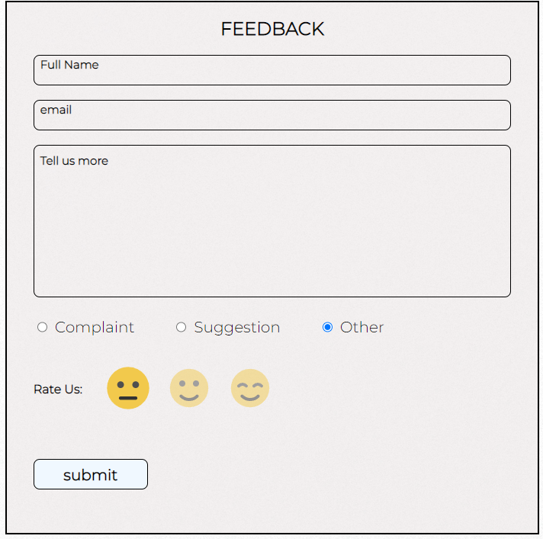

Figure : lowest rating

Accordingly, when we select the middle rating, the lowest rating gets opaque.

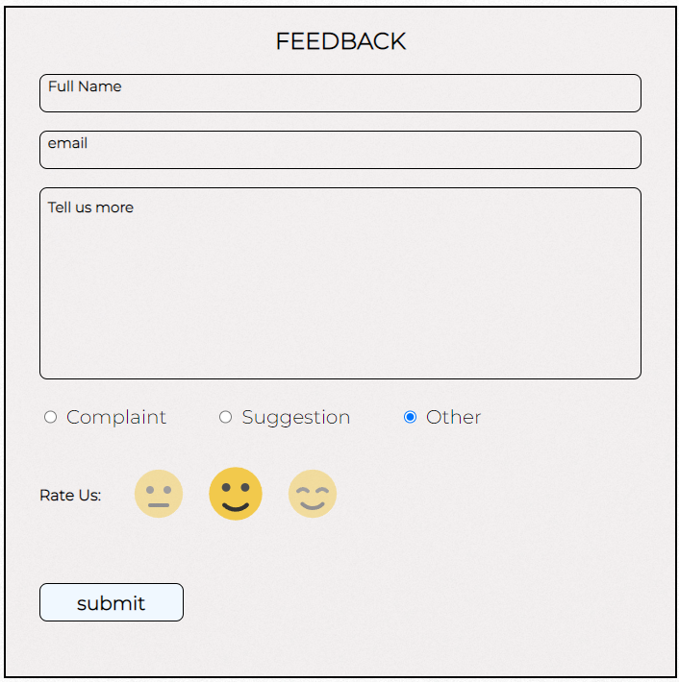

Figure : Middle rating

### Testing slider in feed page

The feed page contains a slider made using JavaScript. Along with images it scrolls text too.

Table : Test 3: Slider in Feed page

|  |  |
| --- | --- |
| Test No: | 3 |
| Objective: | To check if the feed slider works |
| Action: | * Click the next post arrow * Click the previous post arrow |
| Expected Result: | When next post arrow is selected, it scrolls to the next page and vice-versa |
| Actual Result: | The posts changed from next to previous |
| Conclusion: | The test is successful |

As seen in the images below, the next post and previous post arrows changes the posts accordingly.

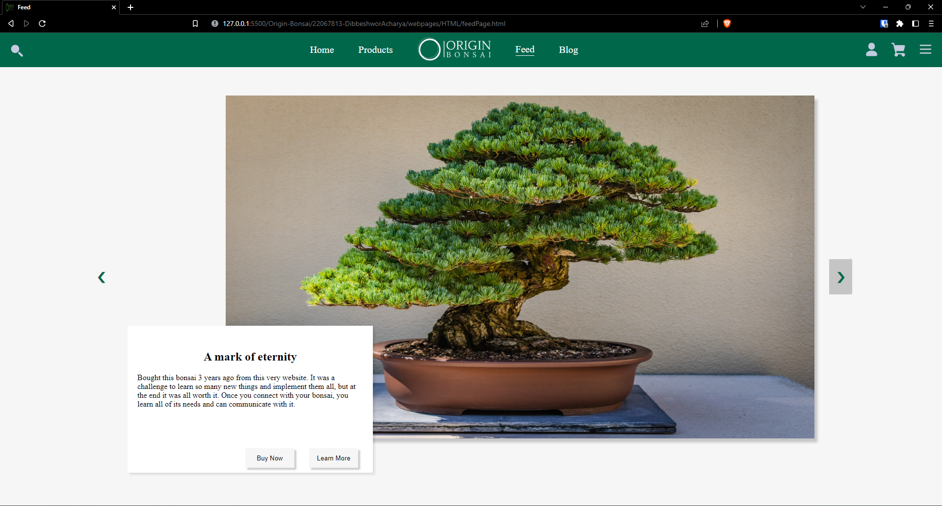

Figure : Before next button

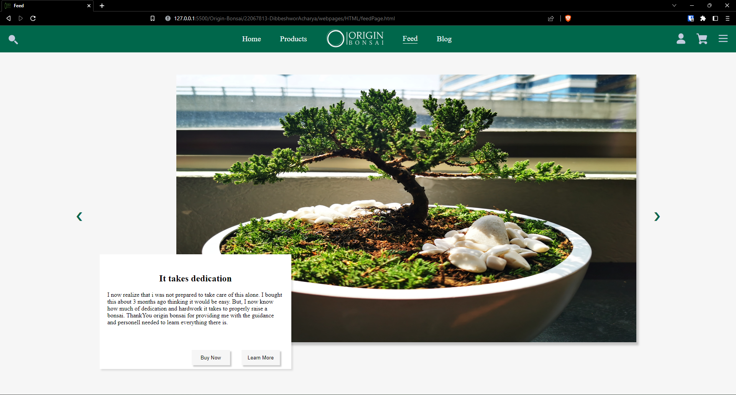

Figure : after next button

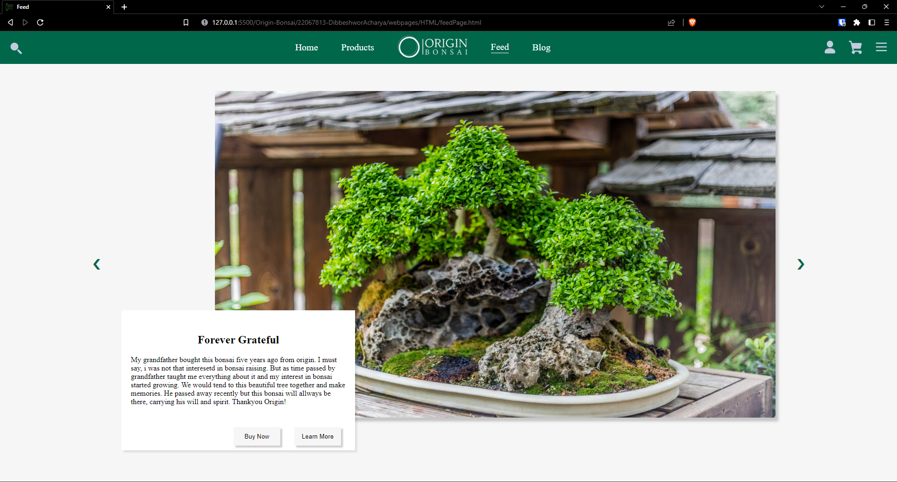

Figure : After previous button

## Navigation Hover Effect Testing

The header navigation elements have a hover effect added to them using CSS hover property. The element hovered over increase in size and is underlined.

Table : Test 4: nav hover testing

|  |  |
| --- | --- |
| Test No: | 4 |
| Objective: | To check if navigation hover effects work |
| Action: | * Hover mouse over navigation elements |
| Expected Result: | When mouse is hovered, the elements should increase in size and be underlined |
| Actual Result: | Hover effects were observed |
| Conclusion: | The test is successful |

As seen in the picture below, when mouse is hovered over the feedback option, it is bigger in size than other elements and is underlined.

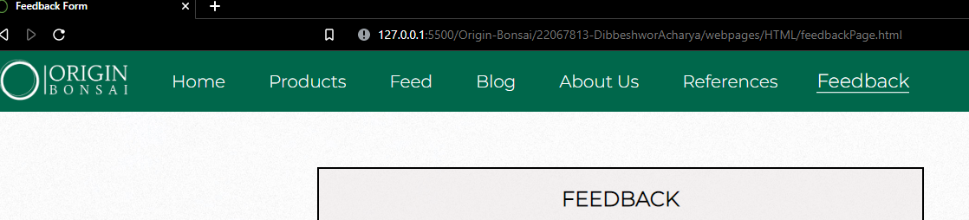

Figure : hover effect in nav bar

## Internal and External Link Testing

### Internal Link

To test the internal link, we will navigate from the home page to products page and from products page to home page.

Table : Internal Link Testing

|  |  |
| --- | --- |
| Test No: | 5 |
| Objective: | To check if internal link works |
| Action: | * Click the products page from home page * Open home page from products page |
| Expected Result: | Each page should open without showing any error |
| Actual Result: | Page opened without errors |
| Conclusion: | The test is successful |

When the product page was clicked, navigation was successful.

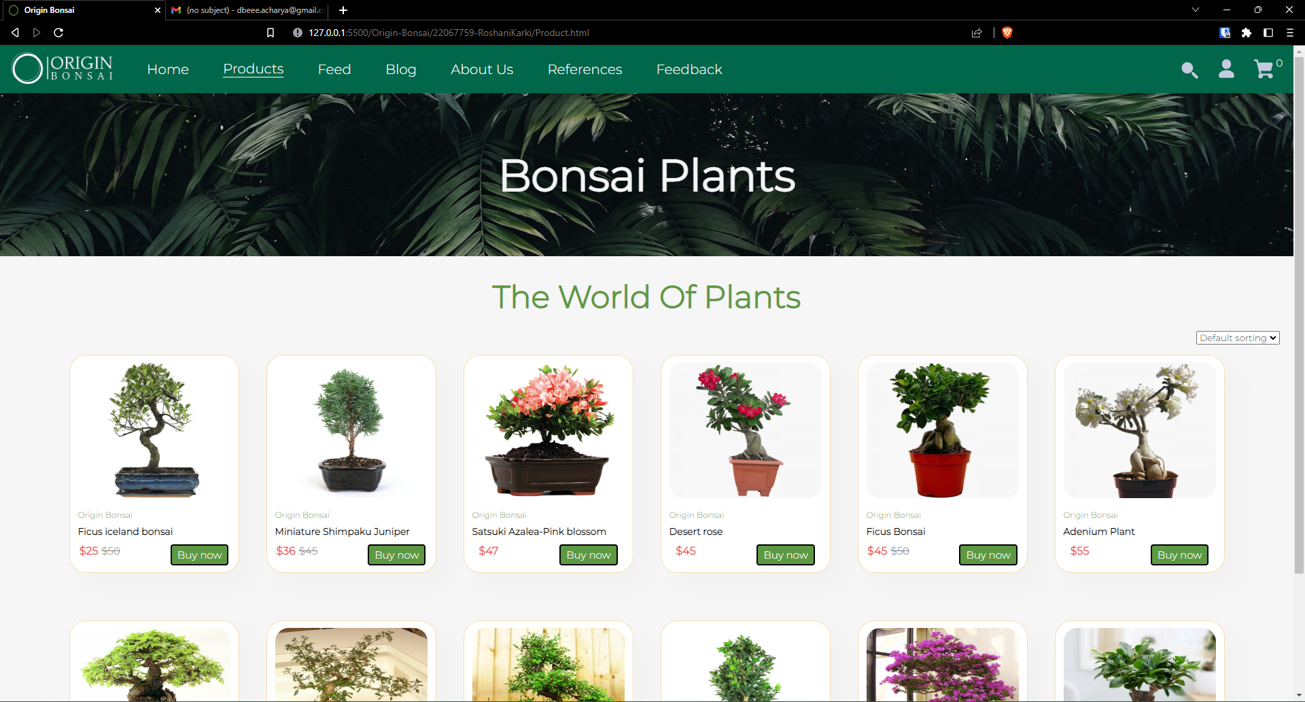

Figure : Home to Products

When the home page was clicked, navigation was successful.

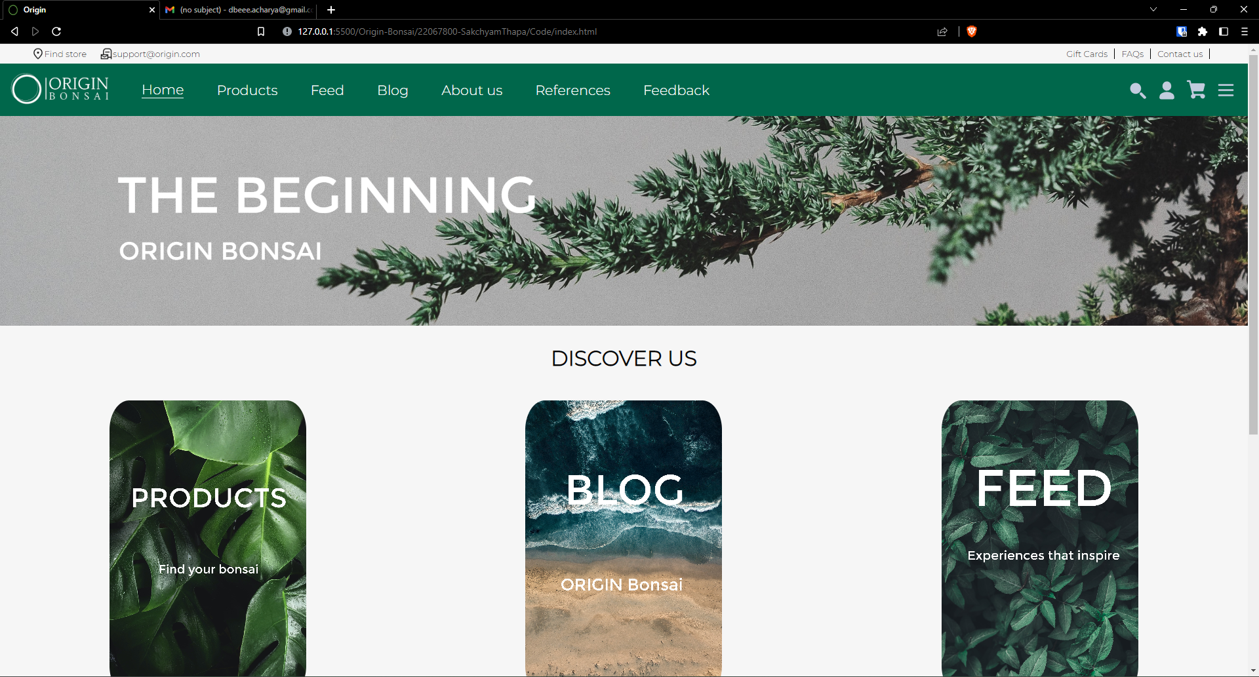

Figure : Products to Home

### External Link

The blog page contains an external link to a research paper. That website was not made by us and is not located within our folders. It is located on a completely different site. We can still access it by providing the correct url.

Table : Testing External Link

|  |  |
| --- | --- |
| Test No: | 5 |
| Objective: | To check if external link works |
| Action: | * Click on the 2017 study link referenced in the blog |
| Expected Result: | Successfully open the research website |
| Actual Result: | Research website was opened |
| Conclusion: | The test is successful |

As seen in the picture below, the link is highlighted and underlined.

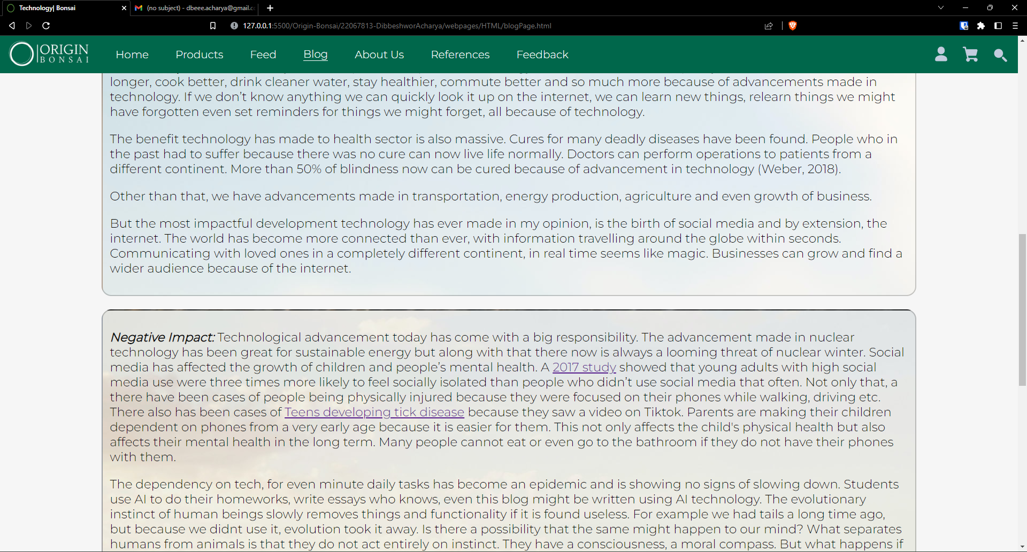

Figure : Before opening link

When the link is clicked, it opens this website:

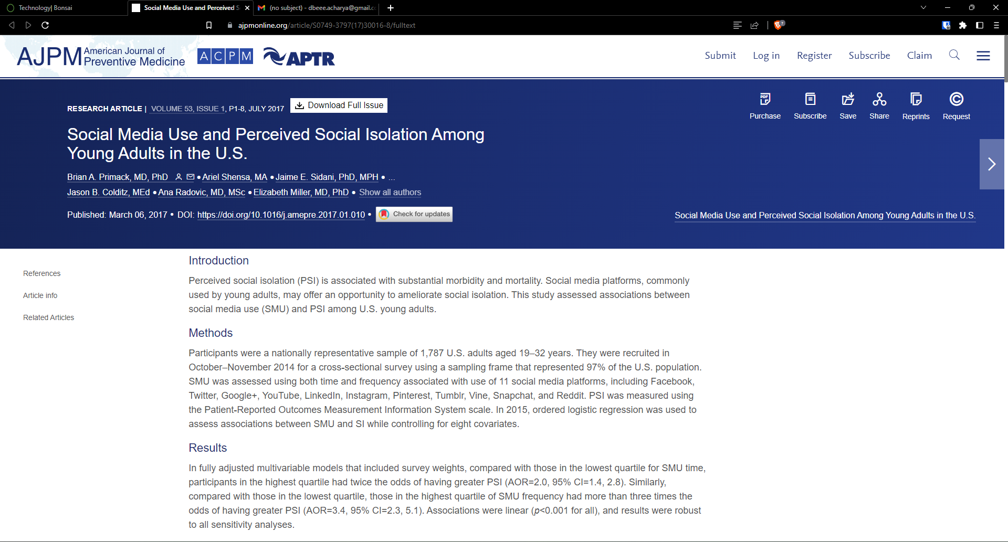

Figure :External Link

# CONCLUSION

In this coursework, HTML5, CSS3, and JavaScript were the primary focuses. The students are tasked with designing and developing an e-commerce website for a store that sells bonsai plants. The website must have at least 5 pages and meet guidelines for technology, design, and structure. The coursework is meant to demonstrate students' understanding of basic internet technologies, website design and development skills, and consideration of usability and accessibility. The accompanying documentation must include a cover page, a table of contents, an introduction, design and implementation details, testing results, and a reflection on the project. The goal of this coursework is to provide students with hands-on experience in creating a functional e-commerce website while considering various technical and design considerations.

As we worked on this project, we gained a lot of knowledge about HTML, CSS, and JS. Making an e-commerce website was a real-life prototype project that required us to create a working model of an actual e-commerce website. This coursework introduced us to various types of attributes and how and where to utilize them. It also broadened our understanding of JavaScript. It helped us comprehend how form validation works on a website. This project also helped us with our problem-solving abilities because we were having a lot of trouble with CSS and JS. While completing the assignment, the tutorial and workshop materials provided by the lecturer and tutor were quite useful.

The hardest part was to take all the individual ideas that each of our team members had and bring out something good of that. A band only sounds good if all of its members are in harmony, likewise, it took us quite some time to get in harmony and create a good looking website.

As seen below, the image on top is what we came up during the first week of doing this project. After a lot of figuring out and ironing out the kinks, the final product looks like the second image.

Overall, despite our little understanding of HTML, CSS, and JavaScript, the project was enjoyable and hard. The difficulties encouraged us to conduct a study and exert extra effort to finish the job as effectively as feasible.

# APPENDIX